Name: Mriganka Patra
Email: mriganka.patra@cognizant.com
Emp ID: 2415820

Day 18
Sprint 1 Submission

Objective: Implement the base CRM logic with record types, automation, visibility settings, and user management.

Task 1.5: As a data manager, I want to bulk upload Account records using the data loader so that initial data can be seeded efficiently.

- Go to setup > home
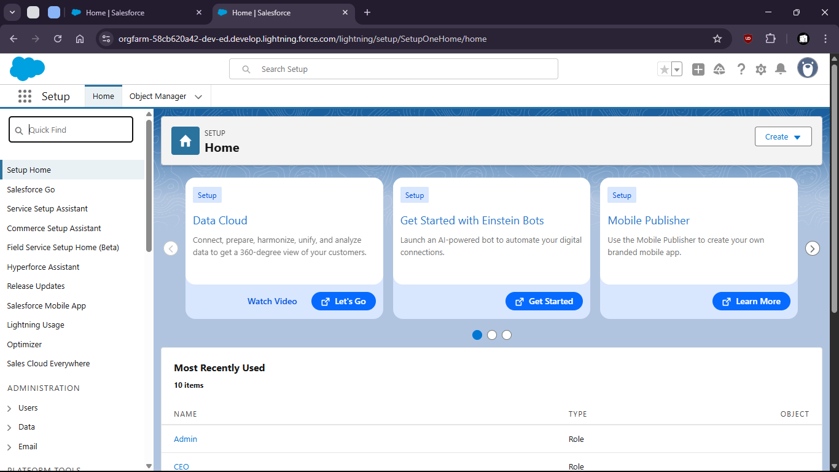

- Search for data import wizard

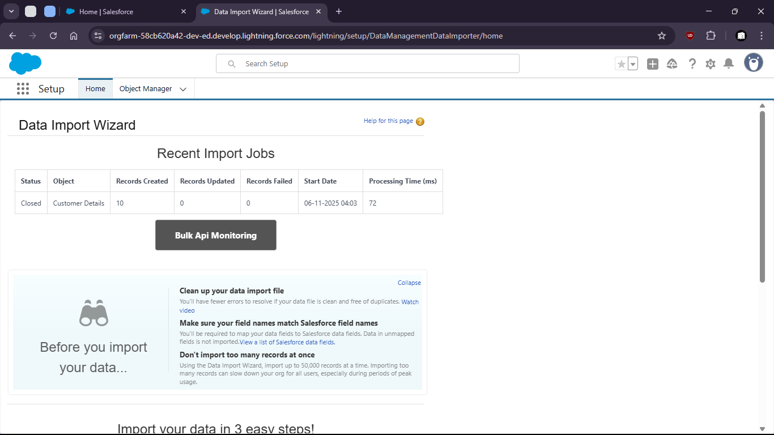

- launch wizard

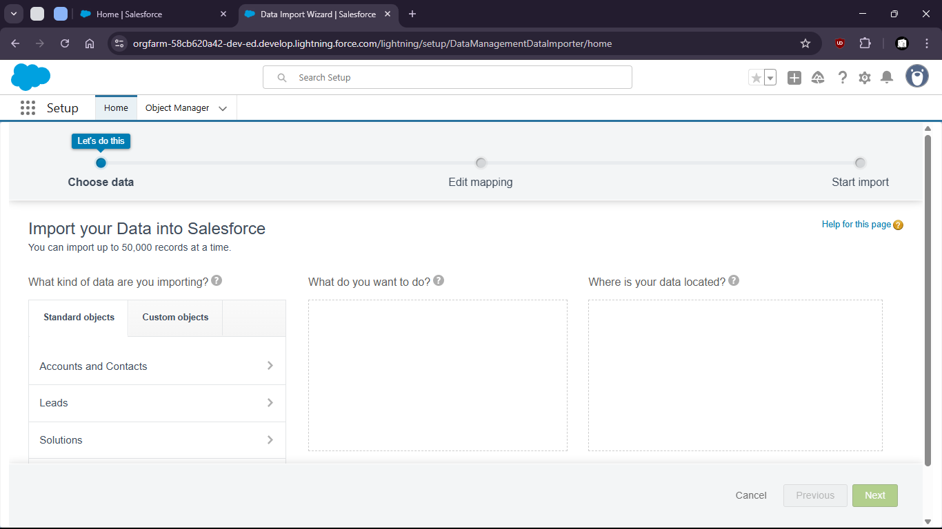

- Select > Custom object > Customer Details > Add new Records > Upload the csv

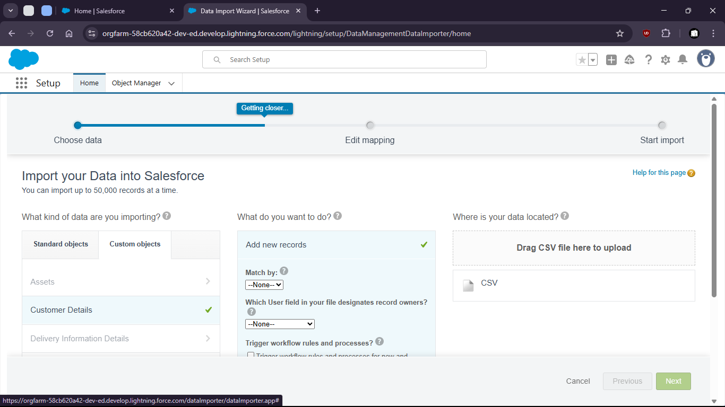

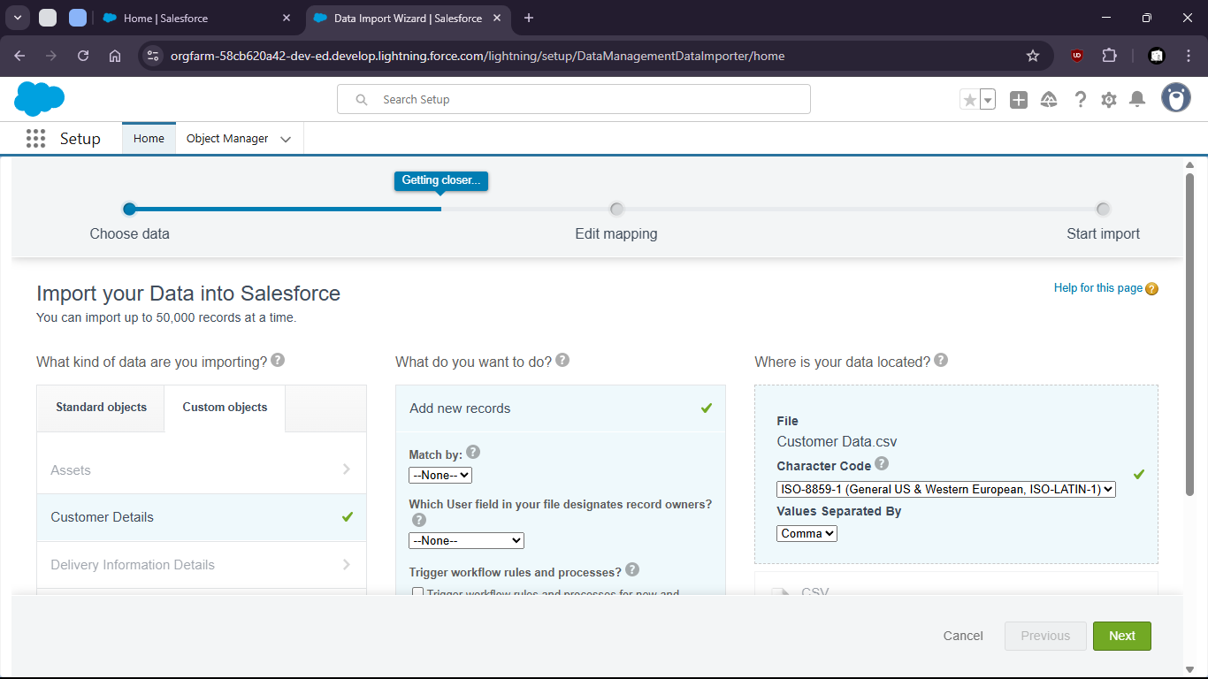

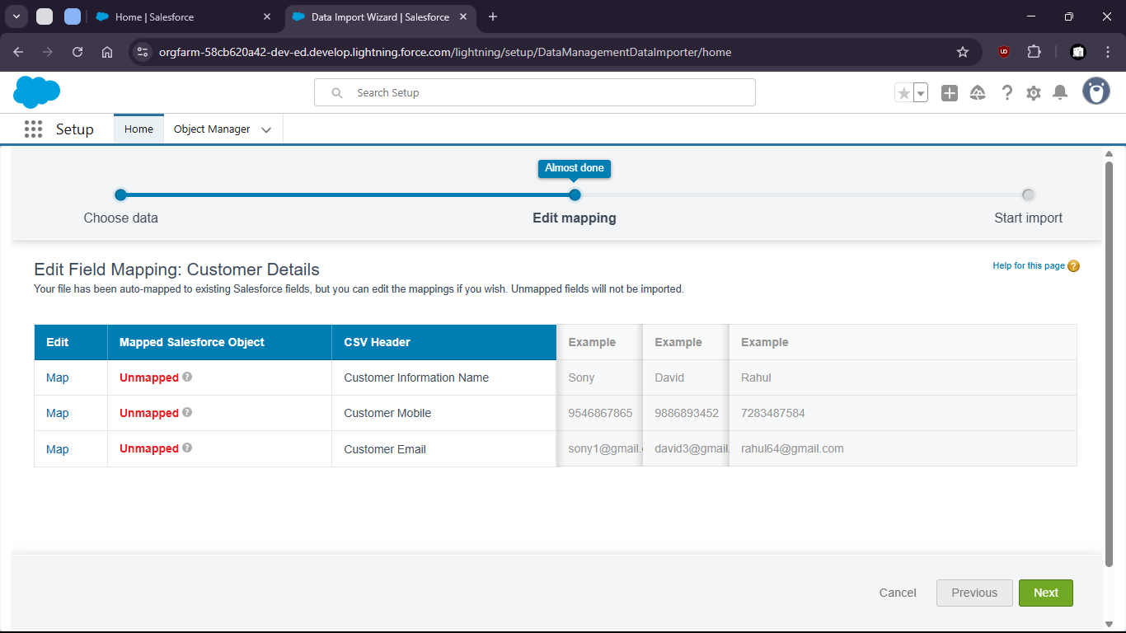
- Now map the fields

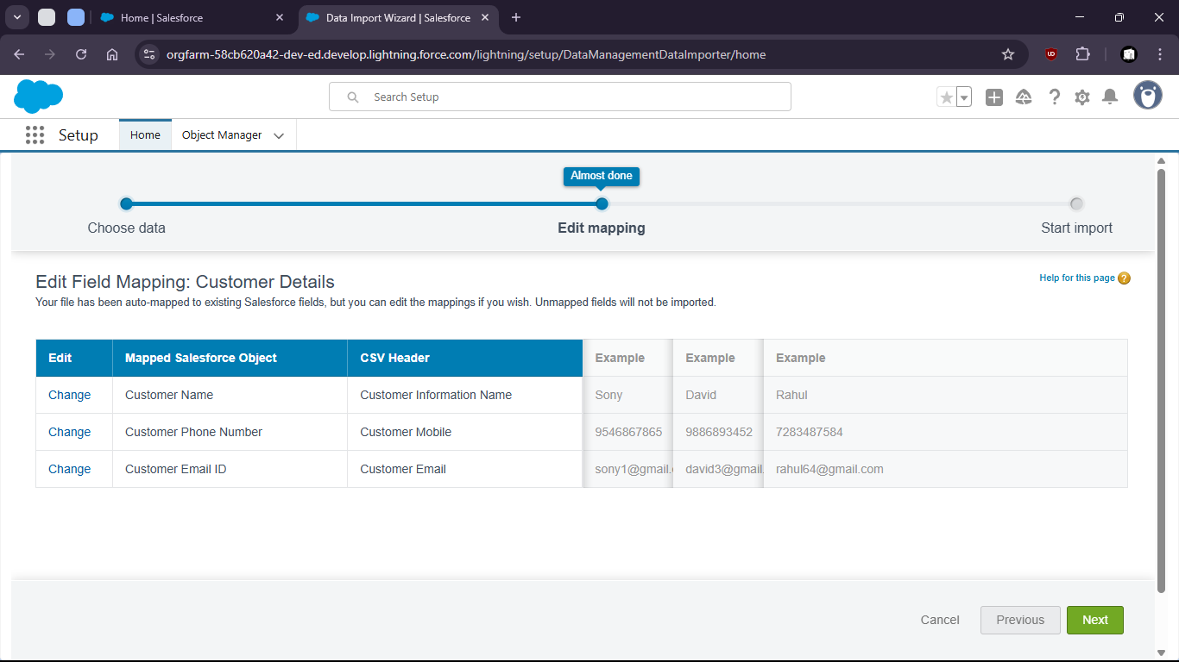

- now start import
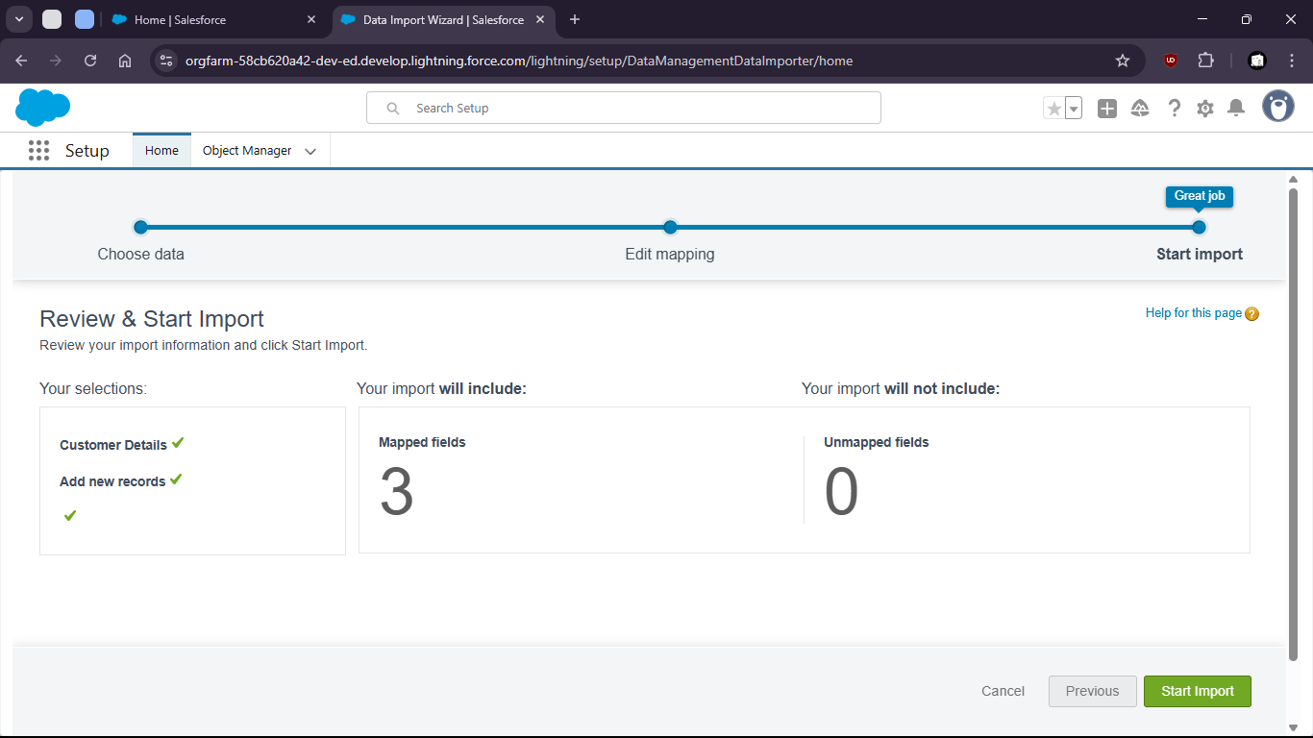

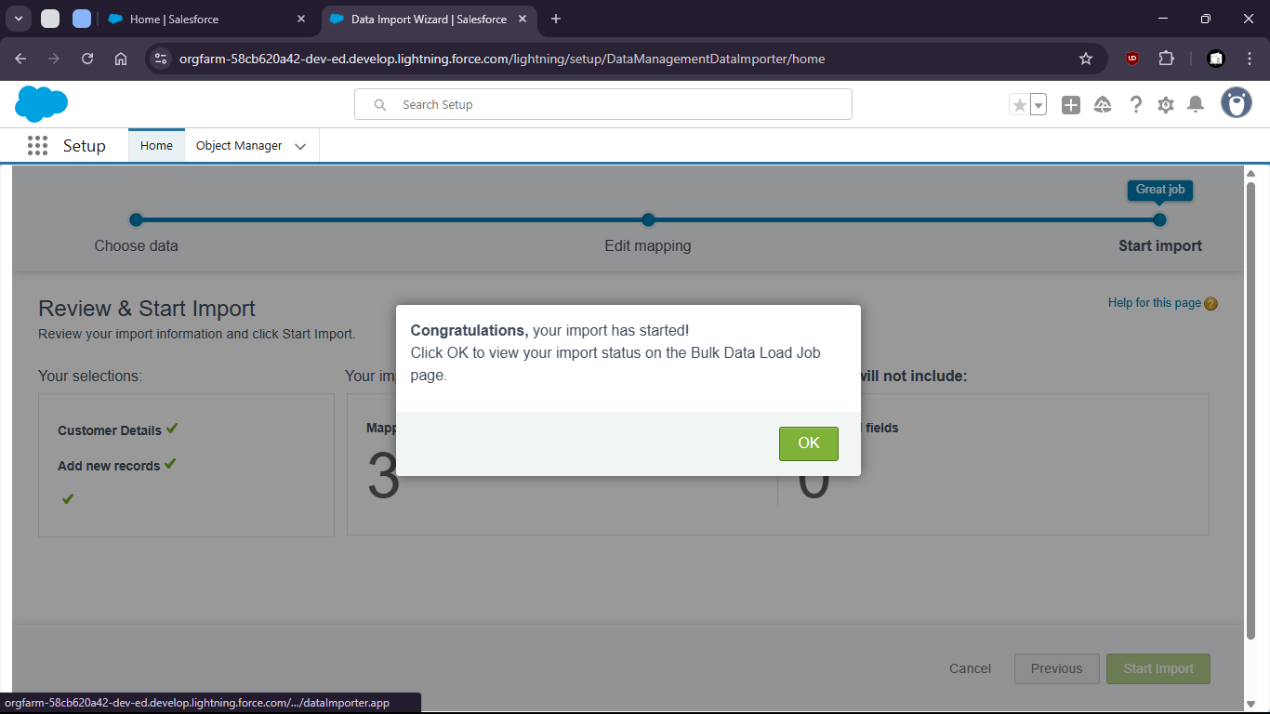

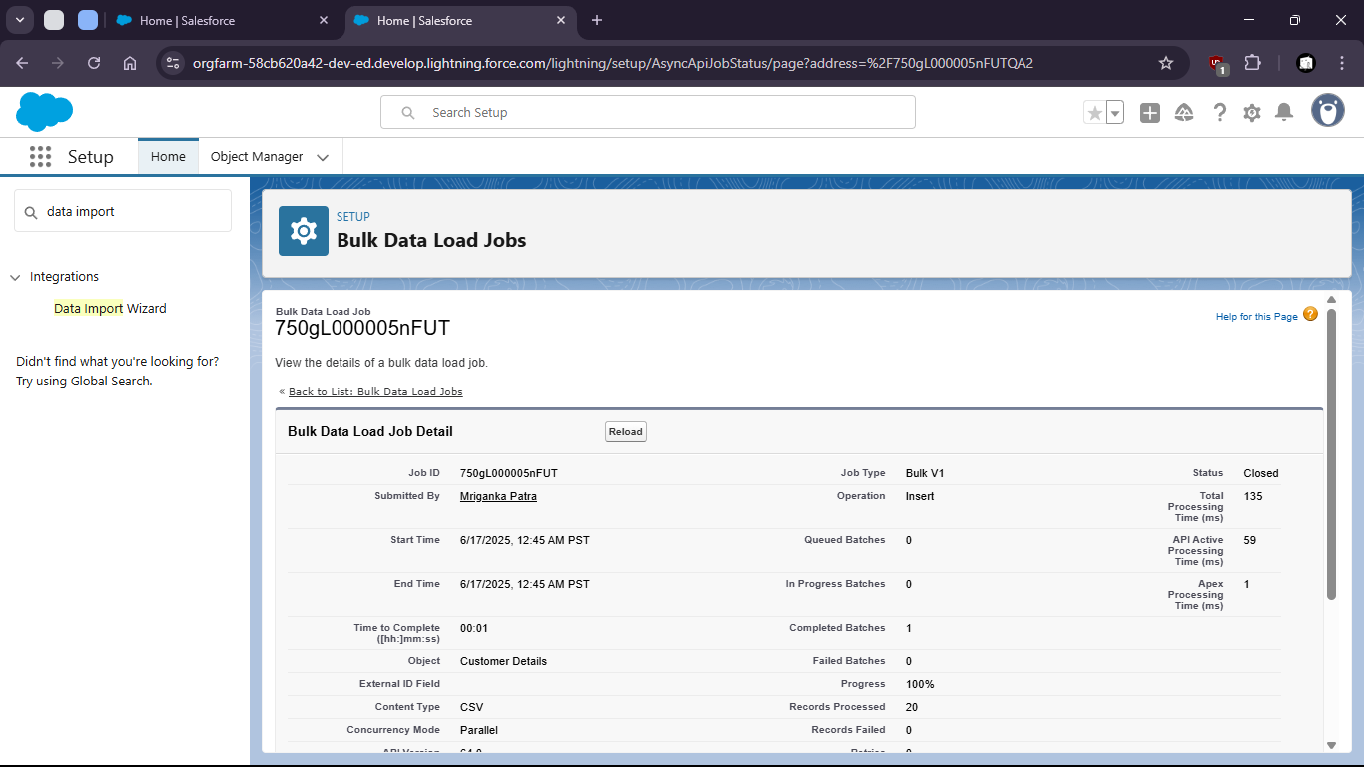

- Now check for all customer details (if upload was successful)

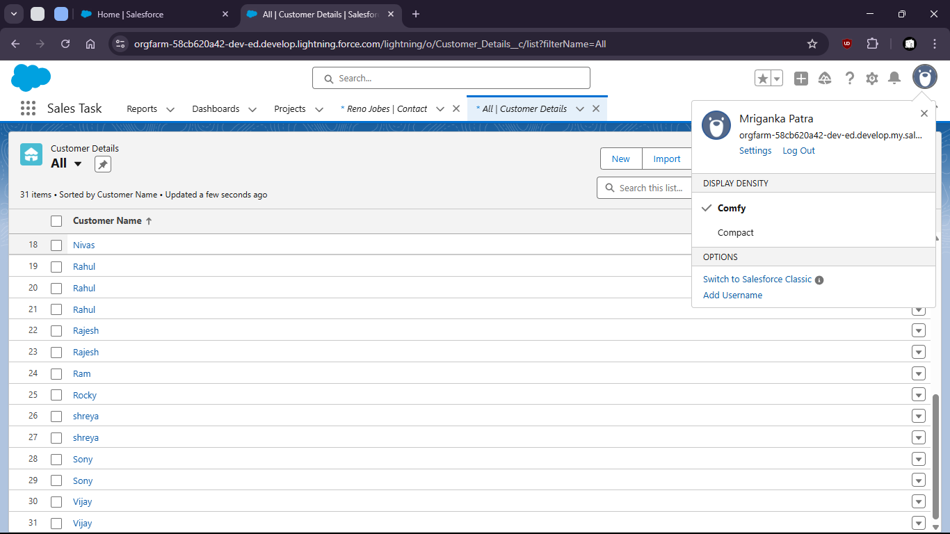
- Uploaded csv file:

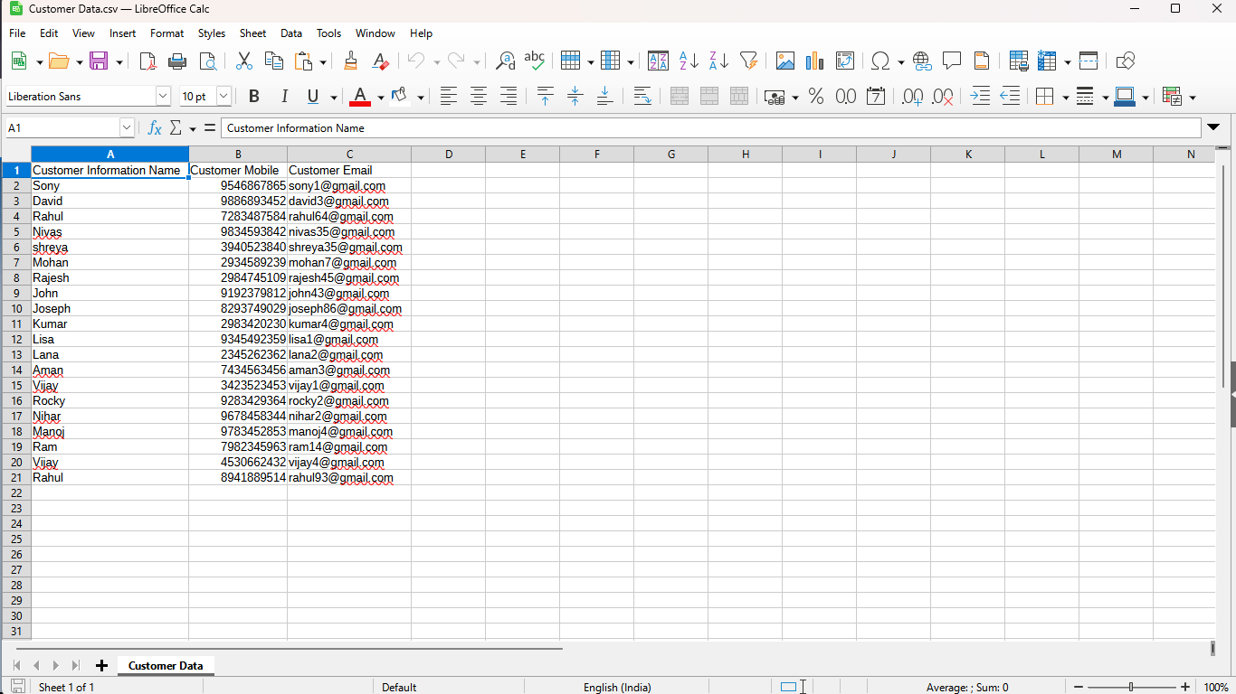

- Validations

